Exercise 1-6

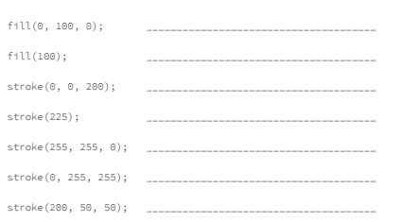

1. Green
2. Grey
3. Blue
4. Grey
5. Yellow
6. Light blue
7. Red